Hand Signals for Garda in front of you Directing the Traffic
Hand Signals for Traffic Behind You

I Intend to Turn Right
I Intend to Turn Right

` 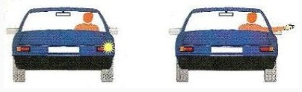 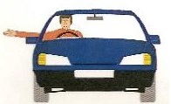

I Intend to Turn Left
I Intend to Turn Left

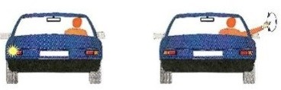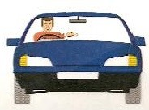

I Intend to Slow Down or Stop
I Intend to go Straight Ahead

